**Hands-On 4 – Difference between JPA, Hibernate, and Spring Data JPA**

**🔸 JPA**

* Java specification (JSR 338) for persistence in Java applications.
* Provides interfaces like EntityManager, @Entity, etc.
* No implementation of its own.

**🔸 Hibernate**

* A widely-used ORM framework.
* Implements JPA.
* Manually handles Session, Transaction.
* More boilerplate code.

**Code:**

Session session = factory.openSession();

Transaction tx = session.beginTransaction();

session.save(employee);

tx.commit();

**Output :** 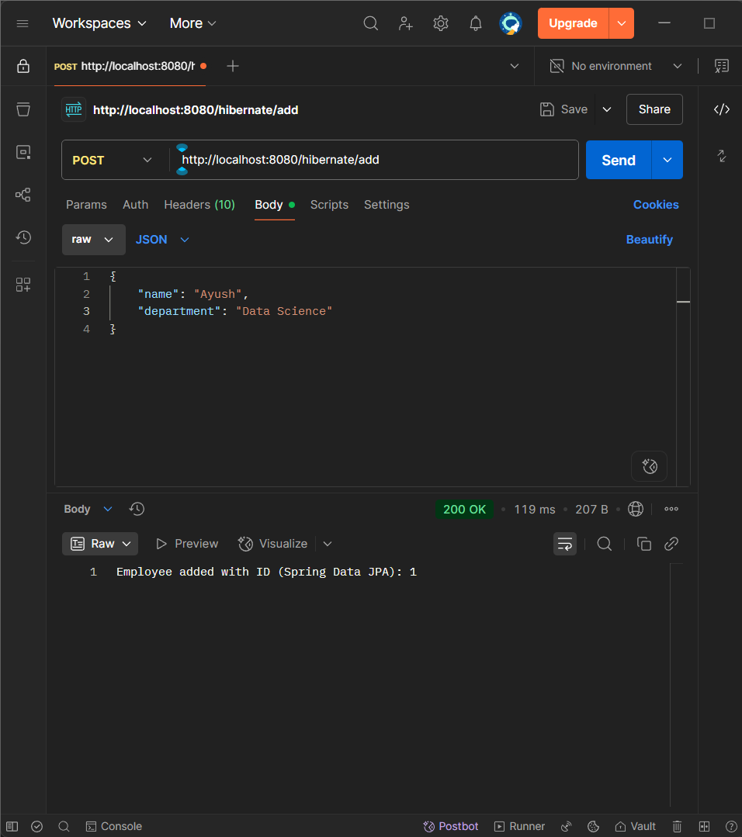

**🔸 Spring Data JPA**

* Built on top of JPA and Hibernate.
* Eliminates boilerplate DAO code.
* Uses JpaRepository and method naming conventions.
* Handles transaction and session automatically.

**Code:**

@Autowired

EmployeeRepository repo;

repo.save(employee);

Output : 